SEND policy
Blue Bell Hill Primary School



Approved by: | Trustees | Date: September 2025
Last reviewed on: | September 2025
Next review due by: | September 2026
Contents
1. Aims………………………………………………………………………………………………………………… 3
2. Legislation and guidance…………………………………………………………………………………………. 3
3. Definitions………………………………………………………………………………………………………….. 3
4. Roles and responsibilities…………………………………………………………………………………………. 3
5. SEND information report………………………………………………………………………………………….. 4
6. Provision for children with SEND………………………………………………………………………………….8
7. Monitoring Arrangements………………………………………………………………………………………….12

8. Links with other policies and documents………………………………………………………………………...12

9. Appendices………………………………………………………………………………………………………….13

1. Aims
Our SEND policy and information report aims to:
- Set out how our school will support and make provision for pupils with special educational needs (SEN)
- Explain the roles and responsibilities of everyone involved in providing for pupils with SEND

Blue Bell Hill is committed to inclusion. Part of the school’s strategic planning for involvement is to develop cultures, policies and practices that include all learners. We aim to engender a sense of community and belonging, and to offer new opportunities to learners that may have experienced previous difficulties. We believe that educational inclusion is about equal opportunities for all learners, whatever their age, gender, ethnicity, impairment, attainment and background. The policy describes the way we meet the needs of children who experience barriers to their learning, which are linked to sensory or physical impairment, cognition and learning difficulties, emotional or social development, mental health difficulties, communication and interaction or may relate to factors in their environment, including the learning environment they experience in school. We recognise that pupils learn at different rates and there are many factors affecting achievement, including ability, emotional state, age and maturity.
Staff will endeavour to make reasonable adjustments, including the provision of additional resources or interventions and organise individual provision, to ensure children are fully able to fulfil their potential, in line with the Equality Act 2010 and Part 3 of the Children and Families Act 2014. The strategy focuses on 4 key areas: early intervention, removing barriers to learning, raising expectations and achievements and strengthening partnerships. Staff will follow the graduated approach to SEND when doing this.

2. Legislation and guidance
This policy and information report is based on the statutory Special Educational Needs and Disability (SEND) Code of Practice and the following legislation:
- Part 3 of the Children and Families Act 2014, which sets out schools’ responsibilities for pupils with SEND and disabilities
- The Special Educational Needs and Disability Regulations 2014, which set out schools’ responsibilities for education, health and care (EHC) plans, SEND co-ordinators (SENDCOs) and the SEND information report
This policy also complies with our funding agreement and articles of association.

3. Definitions
A pupil has SEND if they have a learning difficulty or disability which calls for special educational provision to be made for them.
They have a learning difficulty or disability if they have:
- A significantly greater difficulty in learning than the majority of the others of the same age, or
- A disability which prevents or hinders them from making use of facilities of a kind generally provided for others of the same age in mainstream schools
Special educational provision is educational or training provision that is additional to, or different from, that made generally for other children or young people of the same age by mainstream schools.

4. Roles and responsibilities
4.1 The SENDCO
The SENDCO is Lucy Hunter-James
They will:
- Work with the headteacher and SEND governor to determine the strategic development of the SEND policy and provision in the school
- Have day-to-day responsibility for the operation of this SEND policy and the co-ordination of specific provision made to support individual pupils with SEND, including those who have EHC plans
- Provide professional guidance to colleagues and work with staff, parents, and other agencies to ensure that pupils with SEND receive appropriate support and high-quality teaching
- Advise on the graduated approach to providing SEND support
- Advise on the deployment of the school’s delegated budget and other resources to meet pupils’ needs effectively
- Be the point of contact for external agencies, especially the local authority and its support services
- Liaise with potential next providers of education to ensure that the school meets its responsibilities under the Equality Act 2010 with regard to reasonable adjustments and access arrangements
- Ensure the school keeps the records of all pupils with SEND up to date
4.2 The SEND governor
The SEND governor will:
- Help to raise awareness of SEND issues at governing board meetings
- Monitor the quality and effectiveness of SEND and disability provision within the school and update the governing board on this
- Work with the headteacher and SENDCO to determine the strategic development of the SEND policy and provision in the school
4.3 The headteacher
The headteacher will:
- Work with the SENDCO and SEND governor to determine the strategic development of the SEND policy and provision within the school
- Have overall responsibility for the provision and progress of learners with SEND and/or a disability

4.4 Class teachers
Each class teacher is responsible for:
- The progress and development of every pupil in their class
- Working closely with any teaching assistants or specialist staff to plan and assess the impact of support and interventions, and how they can be linked to classroom teaching
- Working with the SENDCO to review each pupil’s progress and development and decide on any changes to provision
- Ensuring they follow this SEND policy

5. SEND Information Report
In accordance with Section 69 of the Children and Families Act 2014, the school publishes this SEND Information Report on its website and reviews it annually.
The Legislation surrounding pupils with Special Educational Needs and Disabilities uses the term SEND. For the purpose of this document, we will also be using the term SEND. While the statutory term ‘SEND’ is used in formal documentation, in line with our school’s ethos, school staff may also use terminology such as ‘additional needs’ in day-to-day practice to promote inclusive language.
What types of special needs does the school make provision for?
We aim to provide every student with access to a broad and balanced education. This includes the National Curriculum in line with the Special Educational Needs and Disabilities Code of Practice 2015: 0-25 (last updated May 2015). We believe that provision for students with special educational needs is the responsibility of the whole school community requiring a whole school response.
Our work is guided by: The Children and Families Act 2014, the Special Educational Needs and Disabilities Code of Practice 2015: 0-25 (last updated May 2015), regulation 51 and schedule 1 of the Special Educational Needs and Disability Regulations 2014. We support students who may be experiencing difficulties in the following areas:
Sensory and Physical
Cognition and Learning
Communication and Interaction
Social, Emotional and Mental Health
What are the school’s admissions arrangements for children with SEND?
All matters referring to admission arrangements can be found in the school’s admissions policy which can be accessed on the school website. The admission arrangements for all students are in accordance with national legislation, including the Equality Act 2010. This includes children with any level of SEND; those with Education, Health and Care Plans and those without.
How does the school know if children need help?
The school endeavours to highlight and understand any additional needs that children may have, through their SEND Identification Pathway (Appendix One). They do this by gathering information from previous settings, from parents and through early identification. Children, who despite accessing universal provision, still do not make adequate progress in all areas of their learning, will be moved onto the identification pathway. Using the ‘Graduated Approach’ children will then be monitored more closely, using identification paperwork, that is used with all Nottingham City schools. Children who are not making adequate progress, with additional interventions, will be supported more closely by the SENDCO and external experts. Pupil and parental voice will be gained at each stage.
What should I do if I think my child has special educational needs?
Firstly, it is important to have a conversation with your child’s class teacher. It may highlight that we need to monitor your child. From this meeting you can discuss progress and any concerns you may have. You can also ask to talk to the SENDCO to discuss any concerns you may have. If you have concerns over your child’s health or medical needs, you can see your local GP. You can also ask your doctor to refer your child for further assessments; e.g. to a local paediatrician, if you are still concerned.
How will the school know how well my child is doing?
Your child’s class teacher will monitor how well they understand what is being taught within each lesson by listening to their responses, talking to them within lessons, watching to see how they respond and by marking their work. In addition, they will monitor the ways in which your child interacts with other children and adults, within the setting. Your child’s progress will be assessed against the national expectations for children of the same age in all curriculum areas. This will be done as an on-going process and more formally every half term. The class teacher will alter their teaching and the work provided to match your child’s needs and continue to monitor their progress and possibly take advice from the SENDCO if they do not make expected progress. Staff will also monitor how well your child mixes with other children, speaks and listens within school and is able to express their emotions. Within this environment, all staff will monitor emotional, social and mental well-being of children. Children who have been identified as having SEND, provision will be documented on a SEND Support Plan and reviewed three times a year.
How will the school know what they are providing is helping my child make progress?
The Head teacher, Deputy Head teacher and other senior leaders carry out lesson observations in all classes, every half term to ensure that the teaching is effective. They make recommendations to staff on how to provide for individual needs within their class. The Head teacher, Deputy Head teacher and other senior leaders also carry out regular monitoring of children’s books to look at progress, presentation, age appropriate teaching, coverage of the curriculum and differentiation (matching the work provided to the different needs of all the pupils). They will make recommendations to teachers on any areas for development. For children who are on the SEND Identification pathway, class teachers will plan interventions that may require the child to be taken out of class individually or in a small group for extra support or be supported within class. The impact of the interventions on your child’s progress will be monitored by the class teacher and SENDCO.
If the child is highlighted as having additional needs that require specialist teaching, reviews are also held with parents. The child’s progress is discussed and a plan is put together to ensure further progress. The Governing Body will report annually to parents, in accordance with section 69 of the Children and Families Act 2014, on the success of the SEND policy and provision. Children’s progress will provide evidence for the success of the Special Educational Needs policy.
How will the school staff support my child and how will the curriculum be matched to their needs?
The Governing Body will endeavour to ensure that resources are available to support appropriate provision for all students requiring it. All students with SEND will have access to the school’s SEND budget to assist them in a way the senior management deem appropriate. The school may make an application to the Local Authority for some students with significant higher level SEND needs, who will determine whether the level and complexity of need meets the threshold for this funding.
Teachers provide quality first teaching and a scaffolded curriculum to ensure the learning and teaching styles used match the needs and levels of ability of all pupils within the class. If a child needs further support and is placed on the SEND Register parents/carers will be informed and a Support Plan will be completed by the class teacher and teaching assistant detailing the child’s area of need, targets set for the child and what, how, when and by whom support will be given. This will be reviewed every half term by the SENDCO, teacher and teaching assistant, parent and child to assess the effectiveness of the plan. If a child needs further specialised support, the SENDCO will take advice from outside professionals who specialise in supporting children with varying needs.
In some very specific cases a child may need a high level of support and a totally personalised curriculum. In these situations, the school, in negotiation with outside professionals and parents, may apply for additional High Level Needs funding or specialised equipment to meet the needs of the child. In a very few cases, parents/carers may be advised to apply for an Education and Health Care Plan to support very complex and significant needs. The school would support the parents/carers in this process. More information can be found at the following link: www.nottinghamcity.gov.uk/article/22025/Special-Educational-Needs-SEN-Service
What training have the staff working with pupils with SEND received?
All staff have accessed safeguarding training.
We have 5 qualified first aiders.
A number of staff have accessed moving and handling training for specific pupils.
We have a number of staff who are Makaton trained.
All staff have been trained in Attachment, Autism and Emotion Coaching.
Further staff have been trained in sensory provision.
All class teachers are fully qualified and we have a number of level one, two, three and four teaching assistants. All staff access regular training through INSET, staff meetings as well as through outside events.
The SENDCO undergoes regular training with local and national providers and has the NASENCO qualification.
We have four members of senior management who have undergone the Designated Safeguarding training.
How accessible is the school?
The school has a range of specialist SEND facilities in place. These are:
Toilets and changing facilities suitable for disabled pupils, staff and visitors.
The building is wheelchair accessible throughout
Wide corridors making movement around the building easier for students with SEND.
SEND Sensory and Calming Spaces
High Cost Equipment is accessed through the Local Authority to meet the needs of specific pupils.

Who should I contact if I have any questions or concerns?
For general information about the school you can contact us by:
Telephone: 0115 9151161 Email: admin@bluebellhill.org.uk
For specific information regarding SEND support within school you can contact the SENDCO, Miss Lucy Hunter-James on the above numbers and email.
Who should I contact if I have a complaint or concern about the SEND provisions being made at the school?
The School’s Complaints Procedure should be used if the need arises. Details are available on the school website or from the school office. If a parent or carer has any concerns or complaints regarding the care or welfare of their student, an appointment can be made by them to speak to the SENDCO, who will be able to advice on formal procedures for complaint.
If a parent or carer has any concerns or complaints regarding the SENDCO, an appointment can be made by them to speak to the Head Teacher, who will be able to advice on formal procedures for complaint.
Where can I access more information?
More details about the reforms and the SEND Code of Practice can be found on the Department for Education’s website: https://www.gov.uk/topic/schools-colleges-childrens-services/special-educational-needs-disabilities
Information on the Nottingham City Local Offer can be accessed on the Nottingham City Council’s website: http://www.asklion.co.uk
Further information from the Local Authority can be accessed the link below: https://www.nottinghamcity.gov.uk/information-for-residents/education-and-schools/special-educational-needs-service/
Blue Bill Hill Primary School’s SEND policy is available on the school website found at: http://www.bluebellhill.org.uk/

6. Provision for children with SEND
6.1 Areas of need
Our school currently provides additional and/or different provision for a range of needs, including:
- Communication and interaction, for example, autistic spectrum disorder and speech and language difficulties
- Cognition and learning, for example, dyslexia, dyspraxia
- Social, emotional and mental health difficulties, for example, attention deficit hyperactivity disorder (ADHD)
- Sensory and/or physical needs, for example, visual impairments, hearing impairments, processing difficulties, epilepsy
- Moderate/severe/profound and multiple learning difficulties
6.2 Identifying pupils with SEND and assessing their needs (See Appendix One)
We will assess each pupil’s current skills and levels of attainment on entry, which will build on previous settings and Key Stages, where appropriate. Class teachers will make regular assessments of progress for all pupils and identify those whose progress:
- Is significantly slower than that of their peers starting from the same baseline
- Fails to match or better the child’s previous rate of progress
- Fails to close the attainment gap between the child and their peers
- Widens the attainment gap
This may include progress in areas other than attainment, for example, social needs.
Slow progress and low attainment will not automatically mean a pupil is recorded as having SEN.
When deciding whether special educational provision is required, we will start with the desired outcomes, including the expected progress and attainment, and the views and the wishes of the pupil and their parents. We will use this to determine the support that is needed and whether we can provide it by adapting our core offer, or whether something different or additional is needed. Pupils may be placed on the Monitoring List, before being formally added to the SEND register. School may use the Routes to Inclusion framework to support decisions to place pupils on the SEND register.
6.3 Consulting and involving pupils and parents
We will have an early discussion with the pupil (if appropriate) and their parents when identifying whether they need special educational provision. These conversations will make sure that:
- Everyone develops a good understanding of the pupil’s areas of strength and difficulty
- We take into account the parents’ concerns
- Everyone understands the agreed outcomes sought for the child
- Everyone is clear on what the next steps are
Notes of these early discussions will be added to the pupil’s record using the school’s procedures for recording parental notes.
We will notify parents when it is decided that a pupil will receive SEND support.
6.4 Assessing and reviewing pupils' progress towards outcomes
We will follow the graduated approach and the four-part cycle of assess, plan, do, review.
The class or subject teacher will work with the SENDCO and the Routes to Inclusion Framework to carry out a clear analysis of the pupil’s needs. This will draw on:
- The teacher’s assessment and experience of the pupil
- Their previous progress and attainment or behaviour
- Other teachers’ assessments, where relevant
- The individual’s development in comparison to their peers and national data
- The views and experience of parents
- The pupil’s own views
- Advice from external support services, if relevant
The assessment will be reviewed regularly.
All teachers and support staff who work with the pupil will be made aware of their needs, the outcomes sought, the support provided, and any teaching strategies or approaches that are required. We will regularly review the effectiveness of the support and interventions, and their impact on the pupil’s progress.
6.5 Supporting pupils moving between phases and preparing for adulthood
We will share information with the school, college, or other setting the pupil is moving to. We will agree with parents and pupils which information will be shared as part of this. For some pupils, extended or enhanced transition may be required and parents will be notified about transition procedures.

6.6 Our approach to teaching pupils with SEN
Teachers are responsible and accountable for the progress and development of all the pupils in their class.
High-quality teaching is our first step in responding to pupils who have SEN. This will be differentiated for individual pupils.
We will also provide a range of interventions including but not limited to:
- Handwriting
- Maths
- English
- Phonics
- ELSA
- One to one reading
6.7 Adaptations to the curriculum and learning environment
We make the following adaptations to ensure all pupils’ needs are met:
- Differentiating our curriculum to ensure all pupils are able to access it, for example, by grouping, 1:1 work, teaching style, content of the lesson, etc.
- Adapting our resources and staffing
- Using recommended aids, such as laptops, coloured overlays, visual timetables, larger font, etc.
- Differentiating our teaching, for example, giving longer processing times, pre-teaching of key vocabulary, reading instructions aloud, etc.
- A personalized curriculum within the school’s enhanced provision
6.8 Additional support for learning
We have a range of additional adults, including teaching assistants who deliver interventions, additional learning sessions and in class support. Teaching assistants will support pupils on a 1:1 basis or in small groups when this type of support has been determined to best meet the needs of children. For some pupils, school’s enhanced provision will be used to support their learning.
We work with a range of agencies to provide support for pupils with SEND including but not limited to:
- Whole life disability team
- Early Help
- Educational Psychologists
- The Autism Team
- NPST
- Occupational Therapy
- Community Pediatricians
- The INCLUDE Service

6.9 Expertise and training of staff
Our SENDCO has completed the NASENCO qualification and has a wealth of experience in this role. They are allocated appropriate release time each week to manage SEND provision.
6.10 Securing equipment and facilities
If any specialist equipment or resources are required these are kept in the cupboards in the inclusion office. If any additional resources are required this is discussed with the SENDCO and SLT and a purchase will be made though the school business manager. This is recorded as coming out of the SEND budget.
6.11 Evaluating the effectiveness of SEND provision
We evaluate the effectiveness of provision for pupils with SEND by:
- Reviewing pupils’ individual progress towards SMART targets each half term
- Reviewing the impact of interventions after each half term/term
- Using pupil voice added to SEND Support Plans
- Monitoring by the SENDCO
- Holding annual reviews for pupils with EHC plans
- Holding pupil progress meetings each term
6.12 Enabling pupils with SEND to engage in activities available to those in the school who do not have SEND
Extra-curricular activities and school visits are available to all our pupils, including our before-and after-school clubs.
All pupils are encouraged to go on our residential trips
All pupils are encouraged to take part in enrichment activities including but not limited to sports day/school plays/special theatre performances
No pupil is ever excluded from taking part in these activities because of their SEND or disability.
- Arrangements for the admission of disabled pupils
  - All pupils whose education, health and care (EHC) plans name the school will be admitted before any other places are allocated
  - The school has an enhanced provision that allows some children with complex additional needs to access a curriculum that is bespoke to their needs. This is carefully planned by multiple agencies, school and parents and carers.
  - All lessons in school are differentiated and models and scaffolds are used to support children with learning
  - The school has disabled access changing facilities and toilets
  - The school is accessible via ramps at all doors
  - The school’s Accessibility Plan is published on the school website

6.13 Support for improving emotional and social development
We provide support for pupils to improve their emotional and social development in the following ways:
- Pupils with SEND are encouraged to be part of the school council
- Pupils with SEND access the school’s BLP curriculum
We have a zero tolerance approach to bullying.
6.14 Working with other agencies
School works closely with a wide range of other agencies to ensure all pupils access the support they need. These other agencies include health and social care bodies, local authority support services and voluntary sector organisations. School represents pupils and hosts multiagency meetings, shares information and uses reports for external agencies to support the development of all pupils, including those with SEND in meeting pupils' SEND and supporting their families.
6.15 Complaints about SEND provision
Complaints about SEND provision in our school should be made to headteacher in the first instance. They will then be referred to the school’s complaints policy.
Parents may also seek advice from the Local Authority and have the right to appeal to the First-tier Tribunal (Special Educational Needs and Disability) if they disagree with decisions regarding identification, provision or discrimination.
- Exclusions
- Provision of education and associated services
- Making reasonable adjustments, including the provision of auxiliary aids and services
5.16 Contact details of support services for parents of pupils with SEN
There are many services to support children with SEND within the local area and as a school we are able to sign post parents to these. These include support groups, social care services, respite facilities, children’s center activities and health professionals.
6.17 Contact details for raising concerns
Concerns about pupils can be raised by contacting the school office, by telephone on 01159151161 or by writing to the school, or by emailing the office at admin@bluebellhill.org.uk. Any concerns should be labelled for the attention of the SENDCo
6.18 The local authority local offer
Our contribution to the local offer is to work with other agencies and professionals to ensure the very best outcomes for pupils with Special Educational Needs or Disabilities
Our local authority’s local offer is published here: https://www.asklion.co.uk/kb5/nottingham/directory/localoffer.page?directorychannel=7

7. Monitoring arrangements
This policy and information report will be reviewed by the school SENDCO every year. It will also be updated if any changes to the information are made during the year.
It will be approved by the Board of Trustees.

8. Links with other policies and documents
This policy links to the following documents
- Positive Behaviour policy
- Accessibility plan
- Equality information and objectives
- Supporting pupils with medical conditions policy
- Safeguarding and Child Protection Policy

Appendix 1- SEND Identification Pathway

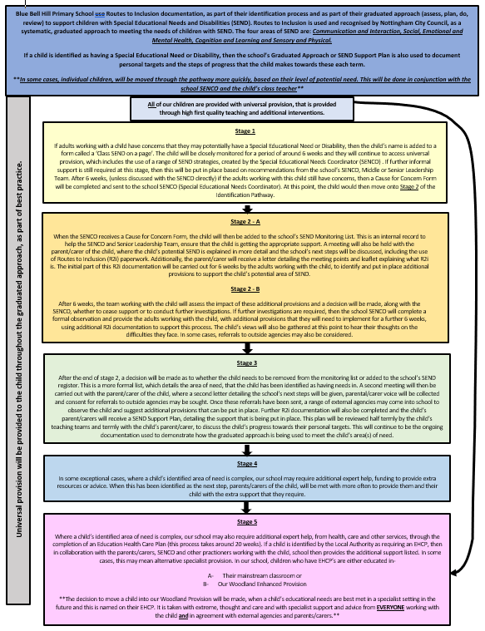

Appendix 2- Behaviour/Inclusion Flow Chart

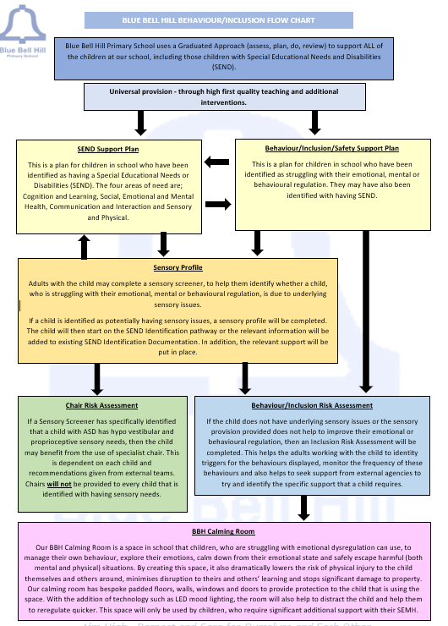

Appendix 3- SEND Support Plan
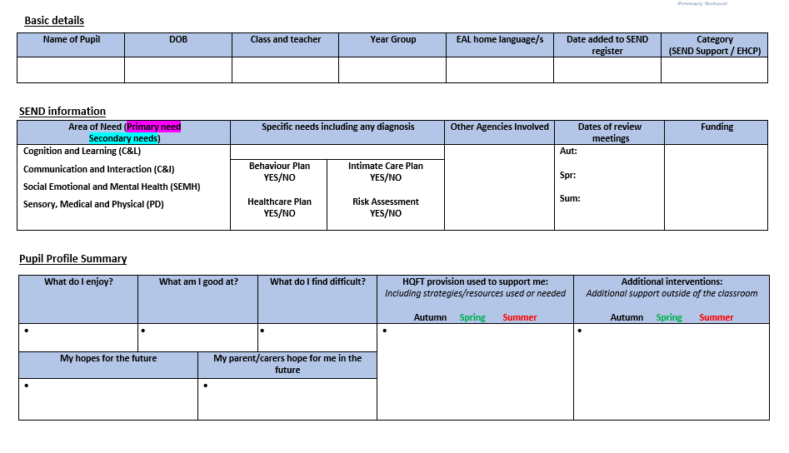
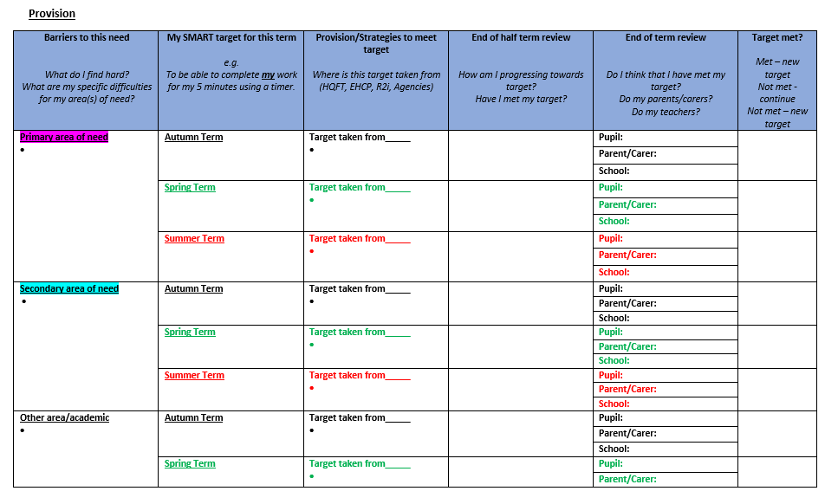

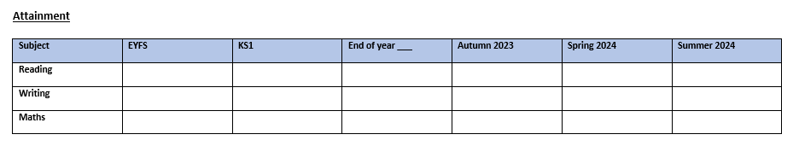

Appendix 4- Behaviour/Inclusion Plan

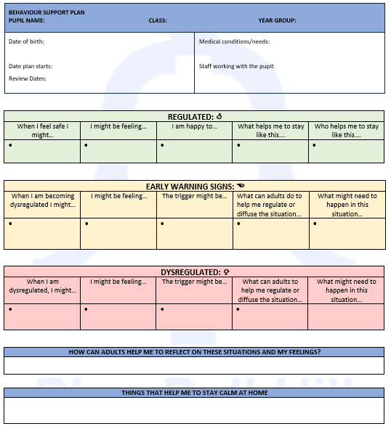

Appendix 5- Sensory Profile



