Positive Behaviour Policy
Blue Bell Hill Primary School



Approved by: | Board of Governors | Date: November 2025
Last reviewed on: | September 2025
Next review due by: | September 2026

At Blue Bell Hill Primary School our vision is at the heart of everything we do.

Aim high - Respect and Care for Ourselves and Each Other

Our school ethos

Everything we do starts with positive relationships – building, maintaining and repairing them. We believe that children deserve our time – time to talk, to explain and to find solutions.

At Blue Bell Hill Primary School, we believe in and practice, a relationship-based and restorative approach to understanding behaviour. This approach is underpinned by 3 key principles:

  - Unmet Needs: Behaviour often reflects unmet needs. Therefore, to change behaviour, we must respond to the unmet need eg. the need to feel safe, hunger, positive self-esteem
  - Individual Influences: Children’s behaviour cannot be fully understood in isolation. It needs to be understood within the contexts or environments in which they develop eg. their family, community, school
  - Relationships: Within trusted relationships, children can learn, accept their individual strengths, accept areas for development and explore strong emotions and experiences.

As a school we remember that discipline means to teach, not to punish. So, in order that we provide opportunities for children to learn positive behaviours, unconditional positive regard is
central to our school ethos.
    - We know that empathy is at the core of building positive relationships: the ability to share someone else’s feelings or experiences by imagining what it would be like to be in that person’s situation.
    - We also appreciate the gravity of acting ‘In Loco Parentis’ (in place of a parent). We have a duty of care towards our children, promoting safety and welfare. The level of this duty of care is measured as being that of a ‘reasonable parent.’
    - We know that, as adults, ‘we make the weather’ and it is up to us to ensure that all children feel safe and happy.

At Blue Bell Hill, we recognise the importance of listening to our children and seeking their opinion. Therefore, our Class Contracts have been created and agreed by staff and children collectively.

Promoting good behaviour

Children learn best and behave best when they know what is expected of them and when they are positively encouraged to behave well. They need to have plenty of opportunities to experience success and also need to be aware that if they do not behave appropriately, they will be consistently and fairly treated. It is therefore important to focus on positive behaviour strategies and our policy and practice reflect this. It is inevitable that some instances of inappropriate behaviour will occur - no positive feedback system will be effective with all children all of the time. Sanctions do, therefore, have a place within the school’s behaviour policy, but they are most effective when used within an environment in which positive strategies are used as a first resort.

Community Contract

A simple school agreement has been drawn up and everyone in school is expected to follow this. The children are reminded of it frequently and parents/carers are given a copy when their child first starts school and reminders are sent out throughout the school year. Our “School Rules” are displayed in every classroom and around school. Our “School Rules” are as follows:

- Be Respectful
- Be Safe
- Aim High

Each of these rules are broken down into sub-sections of ‘to ourselves, to others and to the environment’ (eg. Be respectful to ourselves, be respectful to others and be respectful to the environment)

In support of our ethos we apply the practices outlined in the appendices.
See Appendix 5 “Responding in the Moment.”
See Appendix 6 “15 Things to Build Relationships”

Policy aims and objectives

It is a primary aim that every member of the school community feels safe and respected, and
that each person is treated fairly. We are a caring community whose values are built on mutual
respect and trust for all.

Blue Bell Hill Primary School is committed to the emotional mental health and well-being of our children, staff and parents/carers. We wish to work towards this in all aspects of school life, and to provide an ethos, environment and curriculum that supports the social, emotional and mental health of the whole school community.

It is acknowledged that members of the school community may have very different parenting experiences and views on behaviour. However, the aim of our Behaviour Policy is to bring us all together to adhere to some basic key principles and practices that reflect our school ethos.

Positive approaches

The main focus in school for promoting good behaviour puts the emphasis upon positive strategies and rewarding those children who behave well. Praise can be given in many ways and methods of rewarding children need to be varied and changed regularly in order to prevent them from becoming stale. Children behaving appropriately should be praised for it. Unacceptable behaviour may sometimes be ignored, providing it is not a danger and should then be followed by the praising of the appropriate behaviour of another child nearby. Children should be encouraged to copy the teacher’s example of praising others. Our ‘School Rules’ should be established at the beginning of each school year and the children should be encouraged to remind each other of these where necessary.
Children’s attention will be gained in all areas of school with the use of Signal Pause Insist – teacher claps 1,2, and the children respond with clapping 3,4,5.

Rewards
It is a firm belief at Blue Bell Hill that children are rewarded for positive behaviour. This positive recognition reinforces the positivity that we expect in school. Our high expectations are applied consistently across school and are expected of our children, our staff and our wider school community. Gate$post12
We praise our children in a variety of ways:
- Verbal praise and smiles
- Whole class reward systems in assemblies
- Individual rewards
  - Sticker/stamps
  - Public praise in front of staff
  - Visit Headteacher, Deputy Headteacher or member of SLT for praise
  - MM messages home
  - House points
- Postcard home
- Achievement Assemblies linked to superheroes
- Kindness award

Individual Reward
Children are awarded individual house points and work towards personal ‘savings’ which can be used to gain rewards of their choosing. Points focus on the School values of aiming high and respecting and caring, and the school rules. House Points can be awarded by any member of staff both inside and outside the classroom. Positive messages to parents about their child’s attitude and/or positive work will be communicated face to face at the classroom doors, or through Marvellous Me.

Blue Bell Hill awards
At the end of the year, the child who is seen by his or her peers and by the school staff as being the most supportive or a champion of caring and aiming high receives the prestigious “Trustees Award” with their parents invited to school to witness the presentation in the final assembly of the year.
A reward, once earned, must never be taken away from the child.

A restorative approach to challenging behaviour

We are aware that all behaviour happens for a reason and when we are dealing with children who are at climax point, it is essential to take into consideration de-escalation strategies and the ‘Assault Cycle’ (see appendix 7 and 8). At that moment in time, the child will not be at a point to reflect on their behaviour or discuss their choices. It is paramount that any interactions with the child does not escalate the situation – the child needs to be given time and space.

At Blue Bell Hill, we promote the use of ‘natural consequences’ – with the support of a trusted adult these can help children to change their behaviour. Some examples are: writing letters of apology; repairing damage to property; completing missed work in a playtime. If missed playtimes are happening repeatedly the teacher needs to consider what the deeper issue is.

It is however, recognised that sometimes a more structured and immediate approach is required in order to support the child. The intention behind this is that the child has time to reflect, away from the situation. The behaviour will always be assessed against the School rules and this will be explained clearly to the child.

Dealing with behaviour is a shared responsibility and it is expected that all staff support one another for the benefit of the child. There is a hierarchy of support and responsibility- see appendix 1 for Blue Bell Hill Stepped approach to behaviour. After any of the steps listed within the stepped approach, the staff must adopt unconditional positive regard so that the child knows that they can move forward. If a child has been referred to a member of SLT more than twice in a 1⁄2 term, the class teacher will seek advice from the Base Leaders.
Actions could include:
- home/school diary
- regular MM messages home
- peer buddy
- social group intervention
- pastoral/ELSA referral
- MHST referral
Any behavioural incidents should be recorded using the relevant school system.

Beyond challenging

At times a child’s behaviour may escalate to a point where immediate action is needed in order to keep the child or others safe or the behaviour is deemed too serious for the steps above e.g., verbal/physical abuse, racism, bullying. In this case, the teacher or TA will request the support of the SLT straight away. The Head Teacher will decide what action is needed depending on the circumstances. Wherever possible, the action should be restorative in nature.

Beyond challenging behaviour will be logged on CPOMS, depending on the circumstances.

Minimising the need to use reasonable force (please also see Blue Bell Hill Primary Physical Intervention and Restrictive Practice Policy )

School Expectations
All staff should adopt a positive approach to improving behaviour to reward effort and build self-esteem. We work in partnerships with those who know the child best to:
- Establish the functions of behaviours being displayed
- Understand the factors that may influence a child’s behaviour
- Identify early warning signs that indicate foreseeable behaviours are developing
This approach will help to ensure that the use of early and proactive strategies is common practice. It aims to reduce the incidence of extreme behaviours and supports the reduction of restrictive practices in school.
Staff should, where possible, avoid any type of intervention that is likely to injure a pupil, unless in the most extreme of circumstance where there was no viable alternative. Staff should try to avoid using force unless or until another member of staff is present to support, observe or call for assistance.
Staff are also expected to remember that physical intervention is only one option and for behaviours involving extreme levels of risk it may be more appropriate to gain support from other agencies, including the police.
Staff will be kept informed and have a duty to inform others about the plans around specific pupils who can present risks to themselves and others. This may include information about SEN, personal circumstance and temporary upset.

Using Reasonable Force (please see policy on restrictive physical intervention)
Individual Behaviour Plans
A behaviour plan is designed to support children in making the right choices and educating them with coping strategies and a ‘toolkit’ for positive behaviours.
The plan will be devised:
- Using a reflection and analysis of the behaviour presented and identification of triggers.
- Creating a personalised plan, in line with the school’s policy.
- A meeting between the class teacher and relevant school leaders to agree actions and targets to be set and clear action e.g. referral to outside agencies, pastoral support plan, SALT.
- Planning provision
- Parental meeting to be held to discuss behaviour concerns, triggers and to work through the plan with parents and child.
- Risk Assessment if required
Staff will help children to understand the impact of their behaviour for others following a behaviour incident. This will not be done until the child has been given time to calm and recover following an incident.
Whilst the child is returning to baseline, following an incident, there will be no discussion of what has happened, and the member of staff dealing with the incident will nurture their recovery. This may include offering comfort, sensory room time, drinks etc. Once back at baseline, a discussion will take place around what happened and what the impact of their behaviour has been for other children, staff members, school property etc.
Supporting staff
At Blue Bell Hill we recognise the importance of providing emotional support to all staff in order to help manage stress. We do this in the following ways:
- School leaders and SLT available to support and advise
- Time for reflection
- A culture where the staff have the confidence to share questions, ideas and feelings
- A team approach to finding solutions (you are not on your own)
- Flying High Trust support available
- De-escalation training
Who is the policy for?
This policy is for all children, staff, parents and carers, governors, visitors and partner agencies working within the school and provides guidelines and procedures as to how our school supports and responds to behaviour and emotional distress.
Equality duty
In developing this policy, and in its implementation, we have had due regard to the provisions of the Equality Act 2010 and in particular our need to:
- Eliminate discrimination and other conduct that is prohibited by the Equality Act 2010,
- Advance equality of opportunity between people who share a protected characteristic and people who do not share it,
- Foster good relations across all characteristics - between people who share a protected characteristic and people who do not share it.
The protected characteristics are age, disability, gender reassignment, marriage and civil partnership, pregnancy and maternity, race, religion or belief, sex, and sexual orientation.
Safeguarding
As a school we take all our safeguarding responsibilities extremely seriously. We recognise that young people can be vulnerable in a number of ways and that the dangers in the online world are as much a threat as those in the real world. We have ensured that our staff understand what makes some children and adults more vulnerable to certain risk factors; how to recognise the signs of somebody at risk; and what to do if they have a cause for concern. We include in our consideration of risk radicalisation and extremism; female genital mutilation; child on child abuse; sexual violence and harassment; forced marriage and honour-based violence; and child sexual exploitation. We will ensure that any changes in behaviour or patterns of attendance are identified quickly and that appropriate action is taken swiftly and is proportionate to the level of concern. We will work with the whole school community to ensure all our stakeholders understand our wider safeguarding responsibilities and work in partnership with us to keep our pupils safe.
Zero-tolerance approach to sexual harassment and sexual violence
We are committed to a whole school approach to ensure the prevention, early identification and appropriate management of child-on-child abuse within our school and beyond. We recognise that child-on-child abuse can manifest itself in many ways with some including:
- Sexual Harassment – (defined as the unwanted conduct of a sexual nature, including sexual remarks, sexual taunts, physical behaviour or online sexual harassment)
- Sexual Violence
Pupils are encouraged to report anything that makes them uncomfortable, no matter how ‘small’ they feel it might be.
The school’s response will be:
- Proportionate
- Considered
- Supportive
- Decided on a case-by-case basis
In cases where this child-on-child abuse is identified, we will follow our child protection procedures, taking a contextualised approach to support all children and young people who have been affected by the situation. Some of these behaviours and actions have been referred to in the above ‘sanctions and extreme behaviours section’ and our ‘Child Protection’ and ‘Child-on-Child Abuse’ policies.
Complaints and allegations
Our school aims to be fair, open and honest when dealing with any complaint. We give careful consideration to all complaints and deal with them as swiftly as possible. We aim to resolve any complaint through dialogue and mutual understanding and, in all cases, we put the interests of the child above all other issues. We provide sufficient opportunity for any complaint to be fully discussed and then resolved. For further details please refer to Blue Bell HIll Primary School complaints policy.
We will also make clear to pupils that they have a right, and are able to question/complain about the use of reasonable force.
We will ensure that mechanisms are in place for pupils, parents, carers and staff to voice the opinions, comments or concerns through face to face dialogues, use of home / school diaries or by telephone.

Keeping the policy alive
We firmly believe that this policy is a ‘way of being’. It is at the core of our school ethos. Therefore, it is important that it is evident in our daily practice.
Strategies to keep the policy alive:
- In each Friday briefing SLT will give staff the opportunity to share something related to the policy (top tip, verbal reminder of a key point ...)
- Each 1⁄2 term there will be a base meeting section in which the Base leader will present a scenario for discussion/give the opportunity for staff to problem-solve an issue/share a strategy.

Policy links
This policy links to the following policies in school:
- Relationships and Health Education
- Anti-bullying
- Equality
- Health and Safety
- Child Protection and Safeguarding (linked to KCSIE 2025)
- On-line safety
- Social Media
- SEND
- Staff Handbook/Code of Conduct
- Physical intervention and restrictive practice guidance and policy

Step 3
Pupil moves name to red on personal record—record on behaviour monitoring system
Step 5
Reflecting time with either DHT/HT– remainder of the session
Step 8
Suspension (fixed term) then permanent

Step 7
External agency support
Step 6
Behaviour continues to escalate after the following actions
Step 4 (red plus)
Reflecting time with either the Base leader/FSW/Deputy ( 15 mins)
15 minutes
Appendix 1
Blue Bell Hill stepped approach to behaviour
Reflection time at break or dinner, in class with class teacher
• Children spend 10 minutes or their break time completing a reflection activity. Follow this up with a reparative conversation and a reminder of what is expected/necessary for everyone to be able to learn, and align with the school values.
• Teachers may consider a phone call home with invitation to come in and chat but this is not an expectation
• If the child has regulated well, back to class and return to step 1– pupils can return to green , but behaviour has been recorded.

Phone call to be made by to parents by class teacher– behaviour recorded on the monitoring system.
Follow up meeting to be held with relevant stakeholders—record this on the monitoring system
Potential internal suspension
Class teacher: review behaviour plan, liaise with SENCo regarding external agency support

• 4 incidences of step 5/red plus within a 6 week time frame :
Formal solution circle, wider school invited
Class teacher to work alongside SLT/FSW/SENCo and family members to create a behaviour support plan (BBH behaviour/inclusion flow chart– see appendix)
• 2 incidences of step 5/red plus within a 6 week time frame:
Phone call to be made by to parents by class teacher– behaviour recorded on the monitoring system.
HT/DHT to monitor behaviour
Informal circle of adults within base meeting for support and strategies to improve behaviour

Fixed term suspension—between 3-5 days
Permanent suspension– determined by the Trustees
Class teachers, SENCo and relevant leadership engage with strategies recommended by external professionals
Phone call to be made by to parents by class teacher– behaviour recorded on the monitoring system.
HT/DHT to monitor behaviour
Phone call to be made by to parents by class teacher– behaviour recorded on the monitoring system.
Base leader/DH to monitor behaviour for remainder of the day/week– class check ins
Pupil returns to class when regulated

Step 2
Pupil moves name to amber on personal record, engage in reflection time
Step 1
Reminder 1 + warning 2
Remember that each session the class teacher will remind the children about the school values of aiming high and respecting and caring for ourselves and others
Pupil moves name into amber space on personal chart, with direct reference to the school rule being broken.
Move child to a reflective working space within the classroom.
5 minutes of separate working and return to task and classroom space

Reminder 1: Within the classroom, whole class reminder, direct recognition of the school rules which has been broken.
Thank pupil for listening to the conversation so they can return positively to the task
Warning 2: Direct conversation with the child within the classroom but to one side. This invitation is given in a positive manner so the child has the opportunity to talk, and then return positively to the task

Appendix 2
Behaviour During Assemblies
Entering the Hall
- Class line up quietly in the classroom
- Class line is organised by teacher into line order so as to avoid particular children sitting together if necessary
- Class walks down corridors silently. Teacher leads but ensures that the line can be seen by them at all times (continuously looking back)
- Class sits down with minimal fuss leaving an isle down the middle
- Staff sit facing the class sideways on (not facing the front of the hall)
Class to be praised at each of the stages above so that they know what they are doing well.
During Assembly
- Encourage all children to sing. During singing, staff to model singing and signing as appropriate
- Throughout the assembly, teacher to continuously check for appropriate behaviour:
- Legs crossed
- Hands on knees or arms folded
- No talking
- Respect for the speaker at all times
- Joining in, hands-up when requested
Class to be praised at each of the stages above so that they know what they are doing well.
If behaviour needs addressing, staff to correct it silently if possible through gestures. Positive behaviour to be praised silently through gestures.
Leaving the Hall
- As entering the hall
- Children are silent until they are back in the classroom

Appendix 3
P.E/Class Activities in the Hall
Entering the Hall
- Before leaving the classroom, instruct the class as to how/where they should sit/stand on entry to the hall eg. “Once in the hall, find a space, sit silently facing the front.”
- Follow procedures for assembly
Class to be praised at each of the stages above so that they know what they are doing well.
During the Lesson
- Noise can compromise safety, particularly in a physical activity; explain this to the class.
General
- At the start of the year, teachers will practise these procedures until they are embedded.
- Staff to stay with classes in the hall for assemblies unless otherwise notified
- Encourage loud, clear voices from the children when they are contributing.
- At all times (in class or in the hall), staff should use a respectful means of gaining the children’s attention.
If staff find themselves giving the same message again and again regarding inappropriate behaviour, the children are not learning it. Staff should stop, re-evaluate, (ask for advice if necessary) and take action. However, as the class learn the expectations, a gentle reminder will be all that is needed as praising all those who are doing what is expected.

Appendix 4
Lunchtime Behaviour Procedures
The School Rules apply at lunchtime just as they do at other times.
Actions will vary from those in the classroom as the environment is so different.
Challenging behaviour
- Quiet word
- Use physical presence
- Time-out (stand with the midday/TA). Child returns to play.
- If child continues to be challenging, Midday/TA radios for (1) Head Teacher (2) SLT member. They will speak to the child about their behaviour:
(a) the reason for the behaviour
(b) the impact of the behaviour on others
(c) how can the child move forward when they return to the classroom? (repair)
And remain in the area for a period of time to ensure that the child is settled.
- If the behaviour continues to be challenging, midday radios for staff as above, the child will be brought inside/out of the hall and remain under the supervision of the staff member for the remainder of lunchtime.
Beyond challenging
At times a child’s behaviour may escalate to a point where immediate action is needed in order to keep the child or others safe or the behaviour is deemed too serious for the steps above e.g., verbal/physical abuse, racism, bullying. In this case, the midday will request the support of the Head Teacher/SLT straight away. The Head Teacher will decide what action is needed depending on the circumstances. Wherever possible, the action should be restorative in nature.

Hall duty
- In the hall, Midday Supervisors are responsible for ensuring that noise is kept at a comfortable level, both for the children and the staff who work in the hall.
- The 5 steps for challenging behaviour and beyond challenging, apply in the hall just as they do outside.
Lunchtime rewards
Midday supervisors should award stickers for positive behaviour and house points where earned. The teacher should be made aware of any rewards given, when the class is handed over. The teacher, class and midday should celebrate the rewards by giving praise and recognition.

Appendix 5

Responding in the Moment

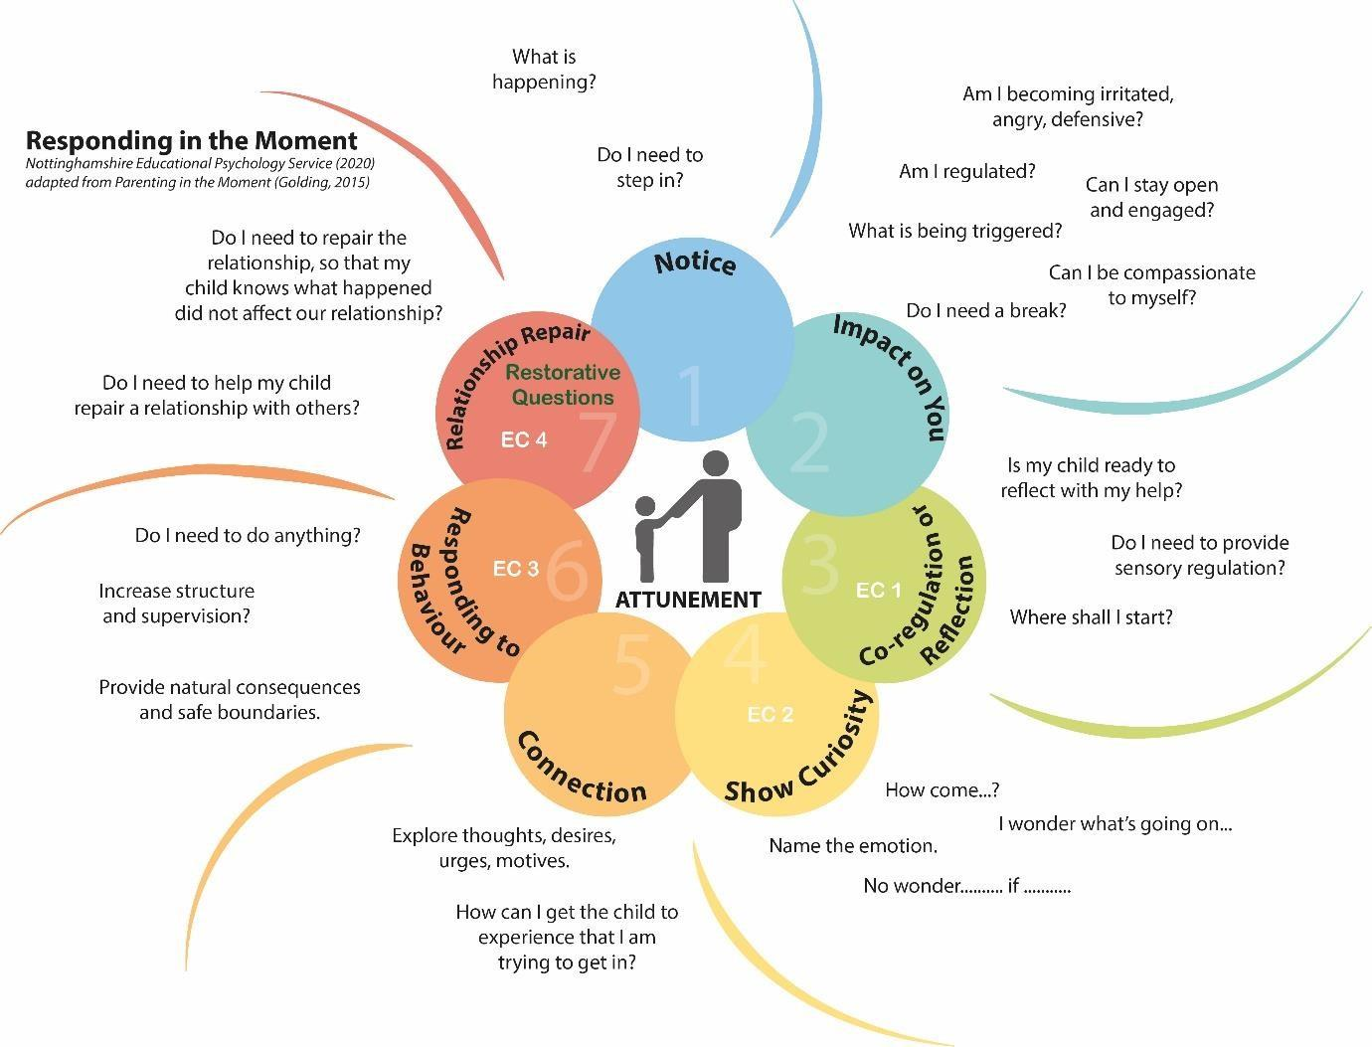

APPENDIX 6
15 Things to Build Relationships - Tips for Staff
- Be who you needed when you were at school. Every child needs a champion.
- Make regular deposits into the positive bank
- Know your children well and allow them to know you well.
- Difficult child or child with difficulties?
- Separate the deed from the doer.
- The best apology is changed behaviour.
- Catch them getting it right more than you catch them getting it wrong.
- Magnify strengths rather than weaknesses.
- Strike when the iron is cold.
- We learn to care by being cared for.
- Smile at children, it’s good for you both.
- There is always a solution – you need to give your time to find it.
- Never assume you deserve respect – you must earn it.
- Calm begets calm.
- Sometimes the child knows best!

APPENDIX 7
The Assault Cycle
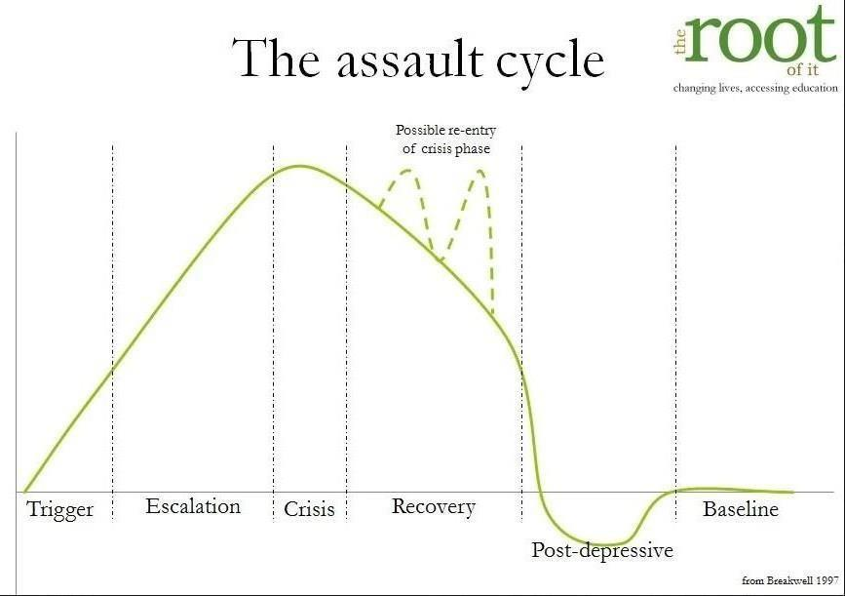
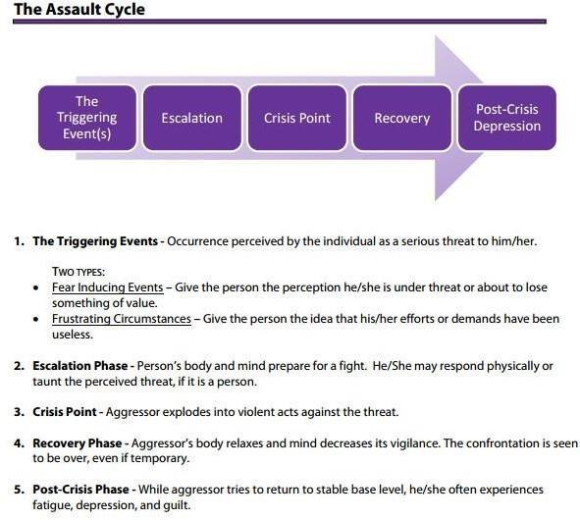

APPENDIX 8
Restorative Questions
Examples of types of questions that could be asked when challenging behaviour:
- What happened?
- What were you thinking of at the time?
- What have you thought about since?
- Who has been affected by what you have done?
- In what way have they been affected?
- What do you think you need to do to make things right?
To help those affected:
- What did you think when you realised what had happened?
- What impact has this incident had on you and others?
- What has been the hardest thing for you?
- What do you think needs to happen to make things right?

APPENDIX 9

Confiscation, searches, screening

Ensuring school staff and pupils feel safe and secure is vital to establishing calm and supportive environments conducive to learning. Using searching, screening and confiscation powers appropriately is an important way to ensure pupil and staff welfare is protected and helps schools establish an environment where everyone is safe.

Searching, screening and confiscation is conducted in line with the DfE’s latest guidance

Confiscation

Any prohibited items found in a pupil’s possession as a result of a search will be confiscated. These items will not be returned to the pupil.

We will also confiscate any item that is harmful or detrimental to school behaviour. These items will be returned to pupils after discussion with senior leaders and parents, if appropriate.

A full list of what my be confiscated is set out in paragraph 3 of the DFE guidance on searching, screening and confiscation.

Searching a pupil
Searches will only be carried out by the Head teacher or specifically authorised staff.

Subject to the exception below, the authorised member of staff carrying out the search will be of the same sex as the pupil, and there will be another member of staff present as a witness to the search.

An authorised member of staff of a different sex to the pupil can carry out a search without another member of staff as a witness if:

- The authorised member of staff carrying out the search reasonably believes there is risk that serious harm will be caused to a person if the search is not carried out as a matter of urgency; and
- In the time available, it is not reasonably practicable for the search to be carried out by a member of staff who is the same sex as the pupil; or
- It is not reasonably practicable for the search to be carried out in the presence of another member of staff

When an authorised member of staff conducts a search without a witness they should immediately report this to another member of staff, and ensure a written record of the search is kept.

If the authorised member of staff considers a search to be necessary, but is not required urgently, they will seek the advice of the headteacher, designated safeguarding lead (or deputy) or pastoral member of staff who may have more information about the pupil. During this time the pupil will be supervised and kept away from other pupils.
A search can be carried out if the authorised member of staff has reasonable grounds for suspecting that the pupil is in possession of a prohibited item or any item identified in the school rules for which a search can be made, or if the pupil has agreed.

An appropriate location for the search will be found. Where possible, this will be away from other pupils. The search will only take place on the school premises or where the member of staff has lawful control or charge of the pupil, for example on a school trip.
Before carrying out a search the authorised member of staff will:
- Assess whether there is an urgent need for a search
- Assess whether not doing the search would put other pupils or staff at risk
- Consider whether the search would pose a safeguarding risk to the pupil
- Explain to the pupil why they are being searched
- Explain to the pupil what a search entails – e.g. I will ask you to turn out your pockets and remove your scarf
- Explain how and where the search will be carried out
- Give the pupil the opportunity to ask questions
- Seek the pupil’s co-operation

If the pupil refuses to agree to a search, the member of staff can give an appropriate behaviour sanction.
If they still refuse to co-operate, the member of staff will try and determine why the pupil is refusing to comply.

The authorised member of staff will then decide whether to use reasonable force to search the pupil. This decision will be made on a case-by-case basis, taking into consideration whether conducting the search will prevent the pupil harming themselves or others, damaging property or from causing disorder.
The authorised member of staff can use reasonable force to search for any prohibited items identified in section 3, but not to search for items that are only identified in the school rules.
The authorised member of staff may use a metal detector to assist with the search.
An authorised member of staff may search a pupil’s outer clothing, pockets, possessions, desks or lockers.
Outer clothing includes:
- Any item of clothing that is not worn immediately over a garment that is being worn wholly next to the skin or being worn as underwear (e.g. a jumper or jacket being worn over a t-shirt)
- Hats, scarves, gloves, shoes, boots

Searching pupils’ possessions
- Possessions means any items that the pupil has or appears to have control of, including:
- Desks
- Lockers
- Bags
- A pupil’s possessions can be searched for any item if the pupil agrees to the search. If the pupil does not agree to the search, staff can still carry out a search for prohibited items (listed in section 3 of SFE guidance) and items identified in the school rules.

An authorised member of staff can search a pupil’s possessions when the pupil and another member of staff are present.
If there is a serious risk of harm if the search is not conducted immediately, or it is not reasonably practicable to summon another member of staff, the search can be carried out by a single authorised member of staff.

Informing the designated safeguarding lead (DSL)
The staff member who carried out the search should inform the DSL without delay:
- Of any incidents where the member of staff had reasonable grounds to suspect a pupil was in possession of a prohibited item as listed in section 3
- If they believe that a search has revealed a safeguarding risk
All searches for prohibited items (listed in section 3), including incidents where no items were found, will be recorded in the school’s safeguarding system.
Informing parents
Parents will always be informed of any search for a prohibited item (listed in section 3). A member of staff will tell the parents as soon as is reasonably practicable:
- What happened
- What was found, if anything
- What has been confiscated, if anything
- What action the school has taken, including any sanctions that have been applied to their child

Support after a search
Irrespective of whether any items are found as the result of any search, the school will consider whether the pupil may be suffering or likely to suffer harm and whether any specific support is needed (due to the reasons for the search, the search itself, or the outcome of the search).
If this is the case, staff will follow the school’s safeguarding policy and speak to the designated safeguarding lead (DSL). The DSL will consider if pastoral support, an early help intervention or a referral to children’s social care is appropriate.

Strip searches
The authorised member of staff’s power to search outlined above does not enable them to conduct a strip search (removing more than the outer clothing) and strip searches on school premises shall only be carried out by police officers in accordance with the Police and Criminal Evidence Act 1984 (PACE) Code C.

More information can be found about this in https://assets.publishing.service.gov.uk/media/62d1643e8fa8f50bfbefa55c/Searching__Screening_and_Confiscation_guidance_July_2022.pdf

APPENDIX 10

BBH Calming Room
As part of Blue Bell Hill’s approach to supporting children, we continually strive to improve their safety and wellbeing, by developing proactive strategies that reduce the likelihood of behaviours that challenge and minimise the use of restraint and physical intervention. This in response to the ‘Reducing the Need for Restraint and Restrictive Intervention’ 2019 Government Report. One of our strategies has been, to create a Blue Bell Hill (BBH) Calming Room.

‘Calming or de-escalation rooms are quiet, safe and secure environments, which provide low levels of stimulation, that enable users to calm down. They are also helpful for’;
- Users to manage their own behaviour
- Users to use to when they recognise that their emotions are rising and need to remove themselves from the situation
- Reducing the risks of a crisis situation
- Reducing the need for periods of physical intervention

Our BBH Calming Room is a space in school that children, who are struggling with emotional dysregulation can use, to manage their own behaviour, explore their emotions, calm down from their emotional state and safely escape harmful (both mental and physical) situations. By creating this space, it also dramatically lowers the risk of physical injury to the child themselves and others around, minimises disruption to theirs and others’ learning and stops significant damage to property. Our calming room has bespoke padded floors, walls, windows and doors to provide protection to the child that is using the space. With the addition of technology such as LED mood lighting, the room will also help to distract the child and help them to reregulate quicker.

The BBH Calming Room, will only be used in the instances below:
A – When a child has recognised that their emotions are rising and requests that they would like to use the space to help them self-regulate
B - As a safe space, where a child has a better chance to compose themselves, after a situation has caused them anxiety or distress, with adult support
C- As space for children to express the exceptional emotions without shame or impact to their mental well being

D- In exceptional circumstances, when a child needs to be taken to a place of safety against their will (using reasonable force) in order to safely manage and/or contain their behaviour and there is no other way of making a situation safe. This includes:
- When use of seclusion is a safer alternative for the child than continued Restrictive Physical Intervention
- To prevent psychological distress because of continued Restrictive Physical Intervention
- When a child/young person demonstrates aggressive or violent behaviours, which constitute a danger to other students and/or staff or significant damage to school property

A member of staff will always (including when withdrawal to the BBH Calming Room is imposed):
- have relevant and regular training to provide the child with the best support
- supervise the child and monitor their progress either:
- just outside the room, if the child is displaying harmful behaviours
- inside the room when- the child is no longer displaying harmful behaviours
- when the child requests their help (as long as the situation is safe)

- ensure that the time spent in in the room (seclusion) is the minimum possible
- support the child to de-escalate the situation as quickly as possible
- ensure that their use of language with the child is clear, regarding when withdrawal to the space is autonomous or imposed
- explain the reasons why the space is being used to the child clearly
- use emotion coaching with the child to support them through an incident
- be available to the child, when they are ready to talk about their emotions, behaviours etc
- have a restorative conversation with the child following an incident and before they resume their normal activities
- explore if any further relationships need to be repaired as a result of the incident and help the child to do this

The child will always:
- be able to use the space on request if they feel that their emotions are rising
- be able to use the space to help them self-regulate
- have an adult to supervise and support them through an incident
- be able to leave the space of their own accord, unless the behaviours demonstrated are likely to cause harm to others
- be told why they are in the space and why imposed withdrawal to the space is or has happened
- be able to put things right and repair relationships

The BBH Calming Room, will never be used:
- as a punishment for a child
- to isolate a child from their peers
- for longer than absolutely necessary

If the BBH Calming Room has been identified as likely to be required by a child:
- it will be available for the child to use regularly if requested/required
- it will be clearly noted on the child’s Behaviour Support Plan, Risk Assessment or SEND Support
- it will be used for the shortest possible period to manage the situation
- the frequency of use will be recorded on:
- a log in school
- on the individual child’s risk assessment, including reasons why and actions taken following use
- frequent reviews will take place:
- on the child’s relevant documentation
- to understand the behaviours that have been displayed
- the triggers for the child
- by everyone working with the child, including external agencies
- if a pattern of persistent use or placements in the room occur, expert assessment of the child by teams will be sought
- any use of force used to place a child into or prevent them leaving the room will always:
- comply with the requirements of section 93 of the Education and Inspection Act 2006
- be recorded in line with the school’s Behaviour Policy

The BBH Calming Room will always:
- be cleaned at the end of each school day
- be ready to use
- contain equipment that is easy to wipe clean to promote hygiene
- contain padding that is wipe clean and water resistant to ensure suitability for children with behavioural issues
- contain equipment that is hard-wearing and able to withstand physical force, wear and tear
- have faulty/broken equipment replaced in a timely manner
- be in accordance our with health and safety policy

Blue Bell Hill’s Graduated Approach to SEND and Behaviour Support
The BBH Calming Room is used as one of the strategies to support children at our school. We are committed to better understanding our children and in doing so reduce behaviour that challenges, among all children. We look at each child as an individual and use assessment of the context in which behaviour occurs, to develop interventions to support our children. Our calming room is just one of these interventions.

In addition, our role in supporting and promoting mental health and well-being (as suggested by DFE’s Mental Health and Behaviour in School 2019) can be summarised as:
• Prevention: creating a safe and calm environment where mental health problems are less likely, improving the mental health and wellbeing of the whole school population, and equipping pupils to be resilient so that they can manage the normal stress of life effectively
• Identification: recognising emerging issues as early and accurately as possible
• Early support: helping pupils to access evidence based early support and interventions
• Access to specialist support: working effectively with external agencies to provide swift access or referrals to specialist support and treatment

We continue also to (as suggested by the Government’s ‘Reducing the Need for Restraint and Restrictive Intervention’ 2019 Report);
• use evidence-based approaches to behaviour support
• have policies in place for promoting positive relationships and behaviours and eliminating unnecessary and inappropriate use of restraint
• have clear arrangements for governance and accountability in respect of behaviour and responses to behaviour that challenges
• involve parents/carers and children as appropriate in decisions relating to behaviour and use of restraint, including through the development and review of Behaviour Support Plans
• ensure staff are suitably trained in understanding the range of communication used by children and young people, minimising the need for, and safely and appropriately using, restraint where necessary and provide opportunities for regular staff development
• understand when expert help is required from specialists
• have a system in place for continually improving assessment and management of risk
• have a system for recording and reporting incidents where required, which enables children and young people who have been restrained on those occasions to express their feelings about their experience
• have a system in place for reviewing how restraint is used in individual cases and patterns and trends in its use, changing practice where necessary to reduce and minimise its use

APPENDIX 11
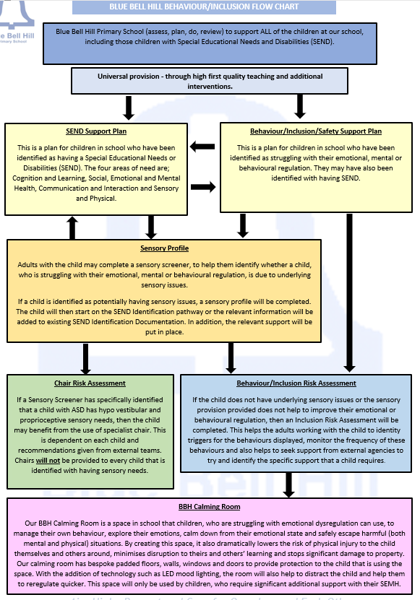
APPENDIX 12

Significant behaviour incidents, definition.

is any event that poses a serious risk to the safety, wellbeing, or dignity of pupils, staff, or the school community. This includes physical aggression, discriminatory or threatening language, bullying (including online), sexualised behaviour, refusal to follow safety instructions, deliberate damage or theft, persistent disruption, substance misuse, safeguarding-related disclosures, or incidents requiring external agency involvement. Such behaviours may trigger safeguarding procedures, parental engagement, or disciplinary action in line with this policy and statutory guidance.

A behaviour incident is considered significant when it meets one or more of the following criteria, aligned with DfE guidance and statutory duties:
- Physical Aggression or Violence
  - Intentional physical harm or attempted harm to pupils, staff, or visitors.
  - Includes fighting, assault, or use of objects as weapons.

- Verbal Abuse or Threatening Behaviour
  - Use of discriminatory, racist, homophobic, or sexually inappropriate language.
  - Threats of violence or intimidation, especially if repeated or targeted.
- Bullying (Including Online)
  - Sustained or targeted bullying (physical, verbal, relational, or cyber).
  - Incidents requiring safeguarding referral or parental involvement.
- Sexualised Behaviour or Harassment
  - Inappropriate sexual comments, gestures, or physical contact.
  - Includes child-on-child abuse and breaches of safeguarding policy.
- Defiance or Refusal to Follow Safety Instructions
  - Repeated or high-risk refusal to comply with adult direction, especially where safety is compromised (e.g. absconding, fire drill non-compliance).
- Damage to Property or Theft
  - Deliberate damage to school or personal property.
  - Theft from pupils, staff, or the school.
- Persistent Disruptive Behaviour
  - Ongoing disruption to learning or school environment despite interventions.
- Substance Misuse or Possession
  - Possession or use of drugs, alcohol, vapes, or other prohibited substances on school grounds.
- Safeguarding-Related Disclosures or Incidents
  - Behaviour that triggers safeguarding concerns, including disclosures made during conflict or distress.
- Behaviour Requiring External Agency Involvement
  - Incidents involving police, social care, or other external agencies.

